Research Brief (Causal Investigations)

Causal Investigation Illustration: The Potential Effects of Winter Climate Change on Black Mangrove

James B. Grace ^{1*}
¹Department of Biology, Concordia University; Montreal, QC H4B 1R6, Canada
* Correspondence: james.grace@concordia.ca; Tel.: +1-337-298-1671

Abstract
Causal methodology rarely describes procedures for conducting causal investigations, despite the historical importance of this process. It is unclear whether human civilizations would exist in their current form without the vast accumulation of causal knowledge upon which technology of all sorts depends. Simply put, causal investigations help us to determine, “how things work”. Recent increases in the literature describing statistical causal inference, which seeks to provide methods for calculating effect estimates for “what happened”, behooves us to discuss modern ideas regarding how causal knowledge of the real world is accumulated to provide a balanced view of the study of causality.
Keywords: causal investigations; causal inference; mechanistic causal investigations.

1. Introduction

The general principles of mechanistic causal investigation are described by Craver and Darden in their 2013 book, In Search of Mechanisms (1). In that treatment, the authors describe causal investigations in terms of the steps commonly taken to establish an understanding of real-world causal mechanisms (2). Note that the term “real-world” distinguishes mechanistic investigations from counterfactual statistical inference studies, which deal with “imagined worlds” that ignore mechanistic information and are poorly suited to building causal knowledge. A summary of the main points and select historical examples in Craver and Darden (1) can be found in Grace 2026 (3).

Figure 1 presents a simplified workflow for real-world causal investigations. Real-world causal investigations usually begin with the identification of a phenomenon of interest. Early in the process, researchers are advised to consult existing knowledge of the system under examination, literature regarding the structures and processes relevant to the presumed mechanism, and behavior of the system to be understood. Progress is made through the accumulation of evidence describing, evaluating, and refining a consistent mechanistic understanding of the phenomenon of interest. Validation and confidence are obtained through sequential studies of real-world consistency with mechanistic understanding. All relevant forms of evidence are considered, and progress is typically evaluated by scientists with appropriate knowledge of the subject. Workflow discussed in more detail in (3).

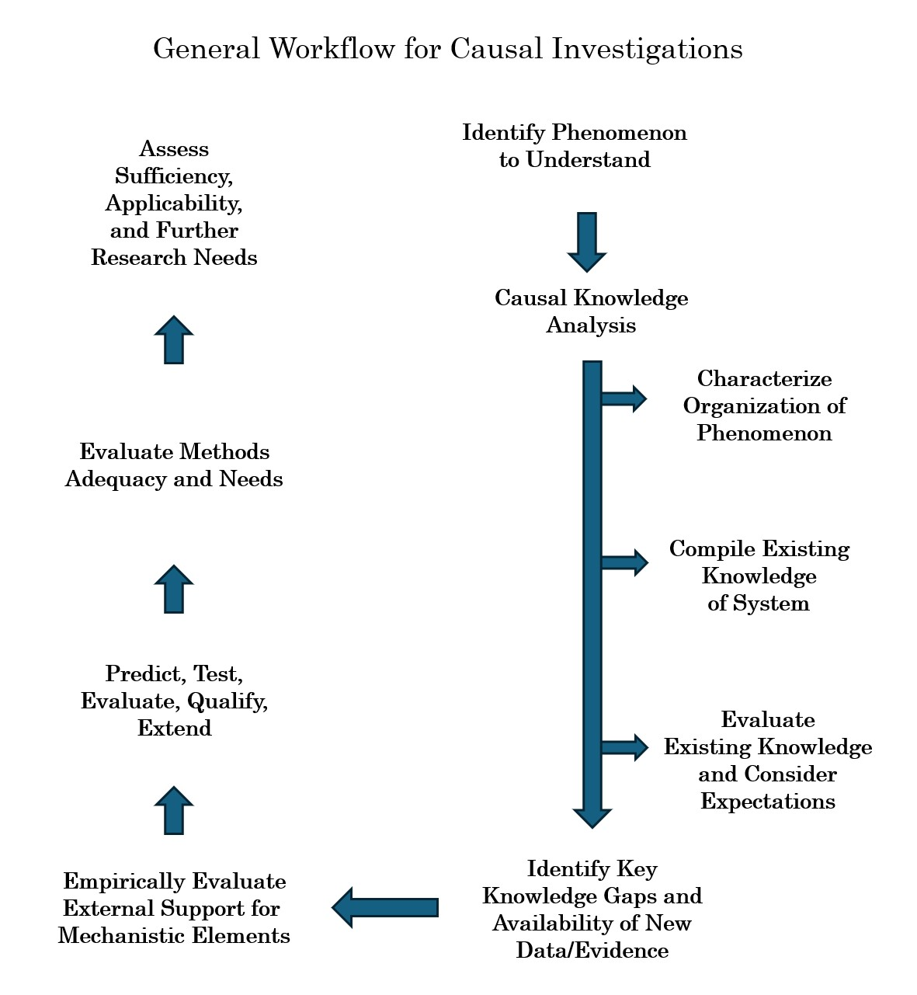

Fig. 1. Example workflow for causal investigations (3).

The investigation described here relates to the broad question of how coastal ecosystems may respond to or be impacted by climate change. An increase in the study of potential climate change effects on ecosystems during the past few decades has fueled substantial research on coastal plant communities, which are on the front line of sea-level rise, but which are also influenced by rising temperatures. This presentation summarizes a subset of the work during the past several years that has progressively advanced our understanding and that provides an exemplar illustration of mechanistic causal investigation.

2. Identification of Phenomenon of Interest - Potential effect of winter climate change on mangrove forest distributions
Pursuit of an understanding of the causal controls of winter temperature regimes on mangroves has been stimulated in recent years by interest in the potential effects of global climate change on coastal wetlands. Sensitivity to freeze events has been reported in the literature on numerous occasions, making clear that winter temperatures are expected to play a major role in limiting northward expansion (4). Further, historical analyses based on early written records and aerial photographs indicate black mangrove has been increasing along its northern boundary (5).

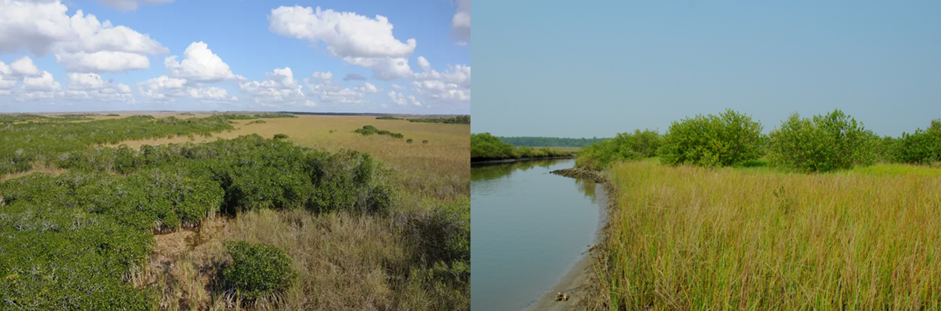

Fig. 2. Two illustrations of the interface between coastal mangrove and marsh vegetation in Everglades National Park (left) and the Atlantic coast Florida (right). https://www.nps.gov/im/sfcn/mangrove-marsh-ecotone.htm and https://serc.si.edu/research/laboratories/animal-plant-interaction/projects/mangrove-expansion-response-climate-change.

3. Characterization of the Organization of the Phenomenon – Expression in the Field

A study conducted in 2013 (6) made an initial characterization of the winter climate threshold associated with transitions between salt marsh and mangrove forest in coastal areas in the southeastern United States. This study reported a minimum temperature of -7.0°C across a 30-year period as a threshold controlling mangrove distribution and abundance. From that information, they developed a simple winter climate-based model to predict mangrove forest distributions for alternative winter climate change scenarios. The form of response (sigmoid, Fig. 3) was consistent with theoretical expectations based on mechanisms of cellular freezing and death. However, the estimated threshold temperature for mortality for black mangrove was not verified in this study, but instead, formed an initial expectation for subsequent observations.

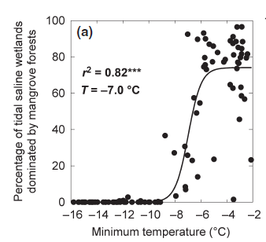

Fig. 3. Estimated threshold temperature (T = - 7.0°C) (6).

4. Characterization of Causal Mechanism

Existing knowledge related to the underlying mechanistic element most directly responsible for survival of freezing temperatures provides a basis for establishing causality in this example (7,8).

Fig. 4. Illustration of mangrove woody tissues anatomy (9). V in panel C shows xylem vessels.

A great deal is known about plant freeze tolerance, but most relevant is knowledge specifically related to black mangrove (Avicennia germinans), which is the mangrove species that extends furthest north in the southeastern United States. In mangrove trees and many other woody plants, the water supply system is disrupted by freezing when air bubbles form in xylem sap and expand to block water transport, leading to tissue death via embolism (7). These processes are ultimately determined by physics, physical chemistry, and biology, and therefore are directly influenced by fundamental causal processes. Lab analyses of field-collected plant tissues were conducted for the most poleward mangrove species. Although black mangrove is the most freeze tolerant mangrove species in North America, it was found to have the largest diameter xylem vessels in comparison with mangroves near poleward range in Australia, which makes it vulnerable to embolism during extreme cold events (Fig. 5). The average winter in the southeastern United States is typically warm enough that black mangroves avoid damage; however, extreme cold events that cause damage and/or mortality occur once every 2–3 decades. Note that black mangroves are covered in regenerative buds that enable them to resprout vigorously following non-fatal embolism events.

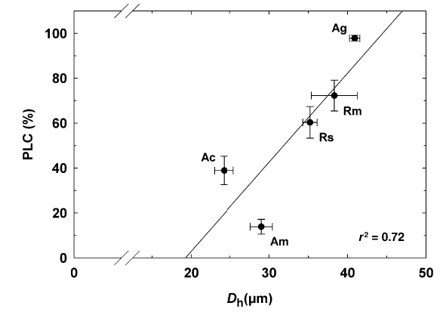

Fig. 5. From Stuart et al. 2007 (7). Freeze-induced percentage loss in stem hydraulic conductivity (PLC) at native xylem tensions as a function of hydraulically weighted vessel diameter (Dh) in the five most poleward mangrove species in North America and Australia. Ag = Avicennia germinans (black mangrove); Rm= Rhizophora mangle; Rs = Rhizophora stylosa; Ac = Aegiceras corniculatum; Am = Avicennia marina. Interpretation is that black mangrove freeze tolerance is limited by its large xylem vessel diameter. Large xylem vessels enable rapid growth and precocious reproduction during years without freeze events, but make black mangroves vulnerable to leaf damage and biomass loss during extreme freeze events that typically occur once every 2-3 decades. Black mangroves are covered in regenerative buds that enable them to resprout vigorously following non-fatal embolism events.

5. Deepening Knowledge of Causal Mechanisms

A laboratory examination of black mangrove tissues collected from across the northern Gulf of Mexico conducted in 2014 (10) examined the relationships between fine-scale variations in xylem vessel diameters and historical winter temperatures. Populations from cooler areas were found to have narrower vessels, likely reducing the risk of freeze-induced embolisms. Vessels were also narrower in regions with high soil salinity due to low levels of precipitation. It appears that the regional variations in vessel diameter observed in the northern Gulf of Mexico reflect responses to cold temperatures and/or salinity.

6. Expanding Characterization of Expression in the Field – Global Climate Controls including Precipitation and Dispersal Barriers

A global assessment of mangrove species and their distributional limits was conducted by an international team of experts (11). An important question arises as to whether global geographic distributions are consistent with regional ones. An assessment for eastern North America (Fig. 6) provides a comparison observation for the pattern previously observed (Fig. 3). While the samples are not completely independent, the result provides some support for the mechanism-based expectation that a species’ freeze-tolerance will be a reasonably well conserved attribute. Studies that examine the immediate influence of extreme freeze events were suggested at this point to obtain more precise estimates.

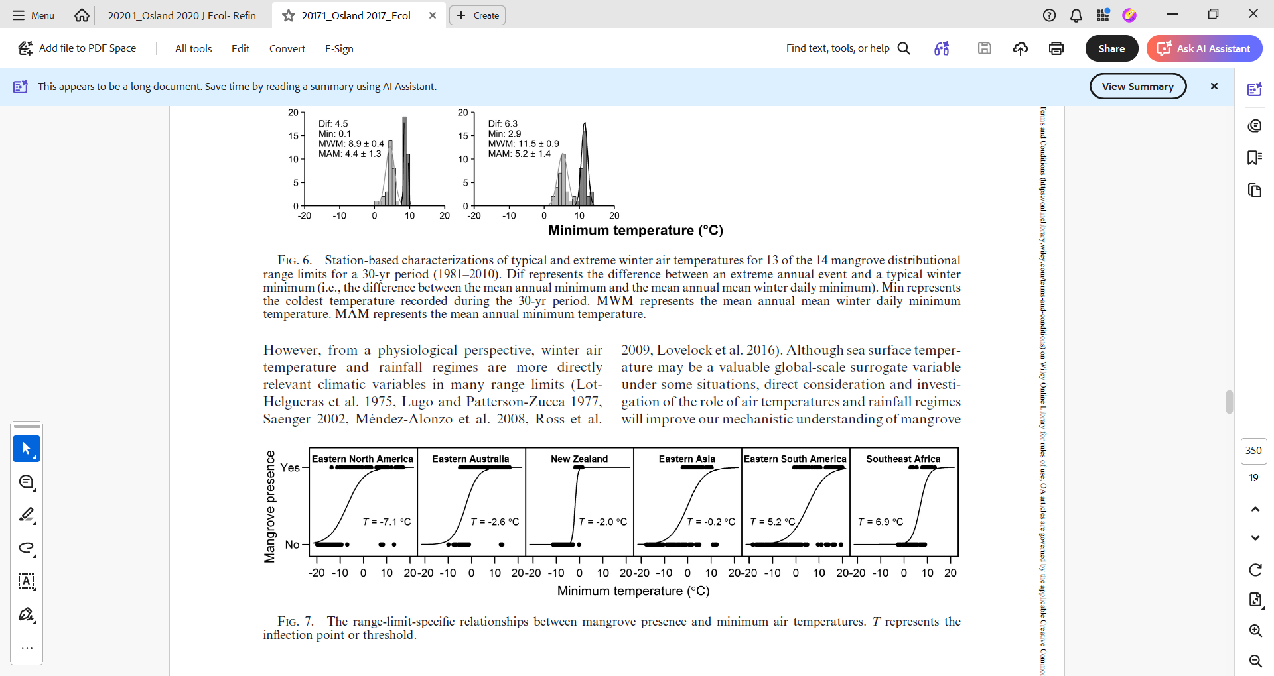
Fig. 6. (left) Excerpt from global examination of mangrove distributions. (right) Distributional threshold for mangroves in eastern North America (11).

7. Refining Tipping Points using Regional Collaborative Networks to Assess Individual Freeze Events
Gathering contemporary data for estimating responses to individual freezes benefits from coordinated planning efforts as well as opportunistic sampling efforts. Osland et al. (12) established the Mangrove Migration Network (MMN) in 2014 to collect field data in anticipation of future freeze events. In 2018, an extreme event occurred, leading to a collaborative effort integrating data from 38 sites spread across the mangrove range edge in the Gulf of Mexico and Atlantic coasts of North America. The 2018 event affected 60% of these sites, with minimum temperatures ranging from 0 to −7°C. Data from before and after the freeze were used to estimate freeze tolerance for black mangrove. The temperature threshold for mortality was estimated to be near -7°C. The temperature threshold for damage was estimated to be -4°C. Between -4°C and -7°C, black mangroves can vigorously resprout and regain biomass.

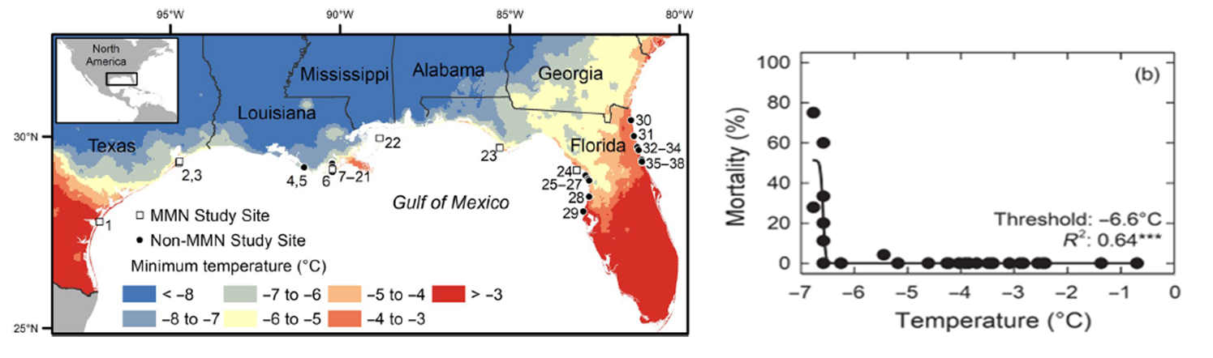
Fig. 7. Estimating black mangrove freeze tolerance based on an extreme freeze in 2018 (12). Map of study sites (a). Field-based temperature threshold for black mangrove mortality (b).

8. Expanding Technical Capabilities – Development of Remoting Sensing Methods
A key component of causal mechanistic investigations is the drive to make new and refined measurements. There is a tremendous increase in the use of satellite and other global data types for assessing changes on the ground. Martinez et al. (13) integrated data from remote sensing with ground-based observations to produce a way to quantify landscape-scale vegetation damage from an extreme freeze event in February 2021 on black mangrove (Fig. 8).

Analyses based on satellite data indicated that damage was particularly severe along the central Texas coast. Further, the freeze event affected more than 2000 ha of black mangrove-dominated coastal wetlands. These data were especially helpful in our comparison of counterfactual and mechanistic causal methods presented in the next section (see 14).

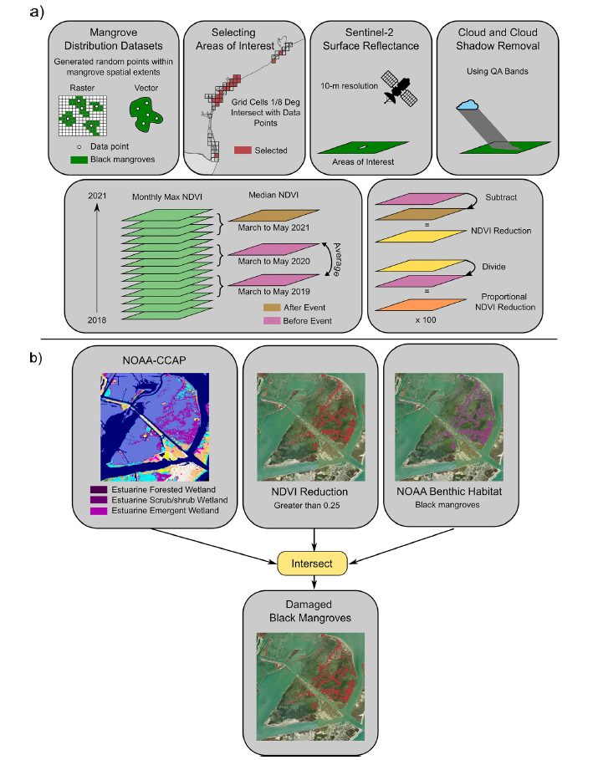

Fig. 8 Geospatial methods for a) selecting mangrove sites and processing satellite imagery using mangrove distribution datasets and b) quantifying the spatial extent of mangrove damage (from 13).

9. Comparing Counterfactual and Mechanistic Causal Methods
Recently, counterfactual statistical methods for causal inference have been heavily promoted for ecological studies. These methods provide some new capabilities but are also restrictive because they (A) require quasi-experimental data processed in such a fashion as to obtain causal effect estimates free from all forms of bias and (B) exclude causal interpretations based on mechanistic knowledge (14). Largely ignored is that counterfactual statistical causal methods are based on simple “imagined worlds” that do not map onto the complexity of real-world causation. Counterfactual methods cannot easily be used to estimate freeze tolerance from a pooled sample because the individual sites cannot be made “counterfactually comparable”. Counterfactual estimates also cannot be externally validated as they are specific to individual datasets.

Counterfactual and mechanistic approaches were both applied to the data from Martinez et al. (13). Fig. 9a shows the study area and distribution of ground-based samples for a February 2021 extreme freeze. The use of satellite data (see Fig. 7) permitted the construction of temporal data records (Fig. 9b), which were analyzed using counterfactual methods. Estimates were computed for each individual satellite data point and are depicted in space in Fig. 9c. Results show that values of counterfactual causal effects were highly variable. Analyses of the theoretical basis for counterfactual methods makes it clear that the quantities produced are simply estimates for “what happened” for each pixel exposed to freezing temperatures. Such causal effects are properties of individual data set and have no mechanistic interpretation or external validation. Estimates of freeze tolerance were obtained by pooling samples, ignoring counterfactual requirements, and using logistical regression. Fig. 9d shows that independent estimates from ground-based and satellite-based data were in strong agreement for this freeze and comparable to those from other freeze event studies (Fig. 6). Estimates from freeze events are reasonably close to estimates obtained from distribution analyses (Fig. 3 and 5), though the short-term results are technically leaf damage as longer-term mortality was not yet verified.
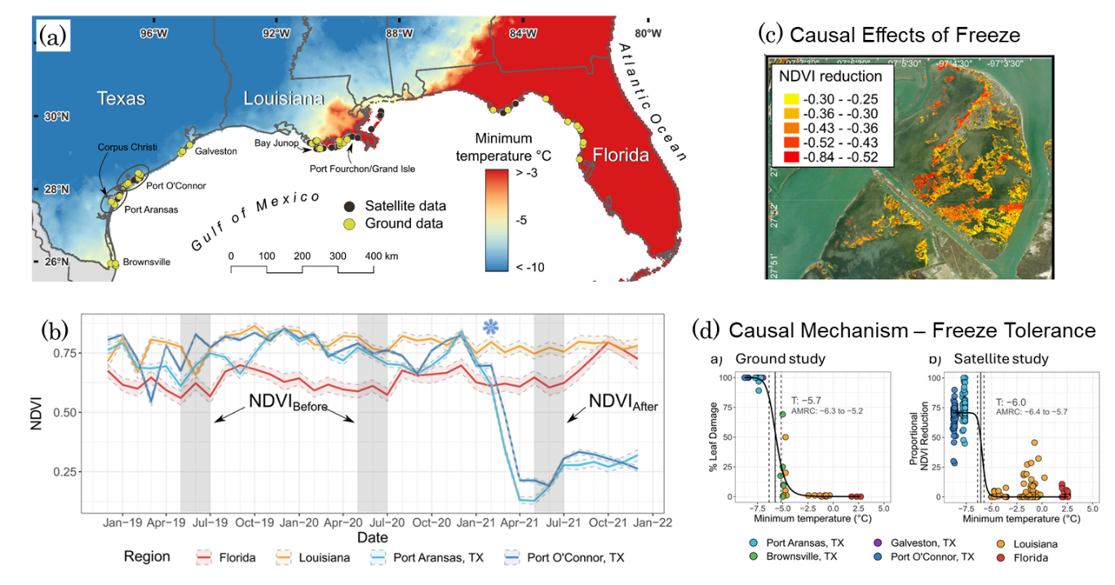
Fig. 9. From (14). (a) Map showing data locations and temperatures during the February 2021 freeze event. (b) Temporal dynamics were used to estimate counterfactual causal effects (displayed in c). (d) Estimates of freeze tolerance based on ground and satellite data.

10. Further Validation – Separate Freeze Events
An Examination of freeze event results may produce threshold estimates that are somewhat different from those based on static distributions. In addition, it could be that the conditions producing cumulative distributional thresholds are more complex than individual freeze events. Thus generally, the more estimates from individual freezes from different locations, where fewer variables are involved, the better. Kang et al. (15) studied a freeze event in Florida in December 2022 (Fig. 10) and found strong agreement with estimates obtained from other individual freeze events (Figs. 6, 9).

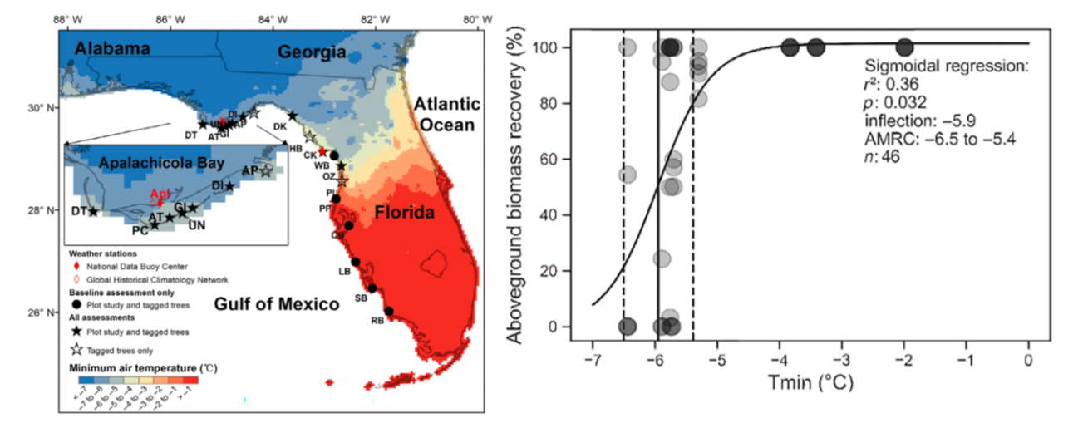
Fig. 10. Freeze event from December 2022 examined (15).

11. Extrapolating and Forecasting – Illustration #1
Managers, decision makers, as well as scientists and the public wish to know the answer to the question, “What might happen in the future?” This interest represents another motivation for mechanistic causal investigation. Several of the above-described studies included initial attempts at forecasting. This aspiration provides important motivation for causal investigations, as well as a reason to avoid lapsing into perfection-seeking based on abstract criteria. In one recent forecasting effort, Bardou et al. (16) developed literature-derived equations to project mangrove responses to greenhouse gas emission scenarios (Fig.11). Confidence in such projections is based on the confidence we have in the essential processes built into the projections. Clearly some phenomena are more reliably forecast, which is another aspect of causal knowledge analysis discussed elsewhere (2).
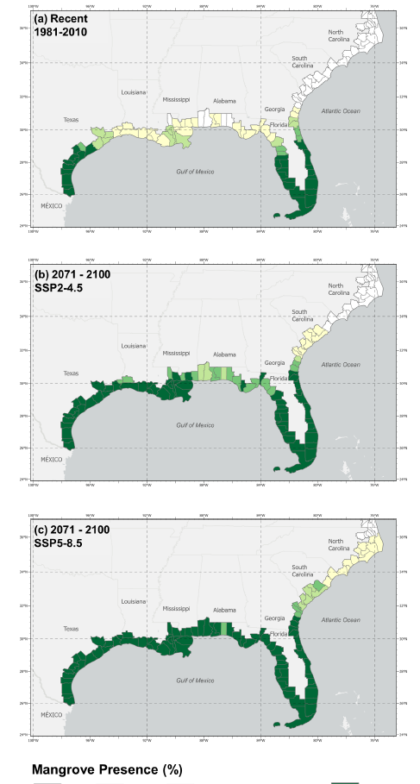
Fig. 11. Projected mangrove responses to climate change scenarios (16).

12. Extrapolating and Forecasting – Illustration #2
Future migration of mangroves will be limited by the species’ freeze-tolerance but will certainly also be influenced by other factors, such as dispersal. Enes Gramoso et al. (17) used high-resolution ocean circulation simulations along with temperatures and historical hurricane data to project future mangrove-salt marsh distributions. Once again, the investigative work to establish the documentable mechanistic behavior of mangroves provides the greatest support for making such simulation studies interpretable.

Postscript
Scientists typically place great weight on results from statistical analysis, particularly with regard to significance testing. Within a mechanistic science viewpoint, statistical analysis is primarily for descriptive purposes, such as estimating and characterizing black mangrove freeze tolerance. Variables may be connected by causal mechanisms and still not exhibit any trend, for example if all data points are below a threshold value. Therefore, causal determination is not typically based on statistical hypothesis testing. That said, since investigations are always a work in progress, statistical analysis may also be used for hypothesis testing when mechanistic knowledge is limited. One final point, the statistical phrase “predictive inference” has no unambiguous meaning in causal science but simply refers to statistical jargon and should be avoided in discussions of causal methods.

References
- Craver, C.F. and Darden, L., 2013. In search of mechanisms: Discoveries across the life sciences. University of Chicago Press.
- Grace, J.B., 2024. An integrative paradigm for building causal knowledge. Ecological Monographs, 94(4),p.e1628. https://esajournals.onlinelibrary.wiley.com/doi/pdf/10.1002/ecm.1628.
- Grace, J.B., 2026. Principles and Illustrations of Real-World Causal Investigations. Research Brief G2026-1. (Link)
- Lugo, A.E. and Zucca, C.P., 1977. The impact of low temperature stress on mangrove structure and growth. Tropical Ecology, 18, 149-161.
- Sherrod, C.L. and McMillan, C., 1981. Black mangrove, Avicennia germinans, in Texas: past and present distribution. Contributions in Marine Science, 24, 115-131.
- Osland, M.J., Enwright, N., Day, R.H., and Doyle, T.W., 2013. Winter climate change and coastal wetland foundation species: Salt marshes vs. mangrove forests in the southeastern United States. Global Change Biology, 19(5), 1482–1494.
- Stuart, S.A., Choat, B., Martin, K.C., Holbrook, N.M. and Ball, M.C., 2007. The role of freezing in setting the latitudinal limits of mangrove forests. New Phytologist, 173(3), pp.576-583.
- Krauss, K.W., Lovelock, C.E., McKee, K.L., López-Hoffman, L., Ewe, S.M. and Sousa, W.P., 2008. Environmental drivers in mangrove establishment and early development: a review. Aquatic botany, 89(2), pp.105-127.
- Mondal, S., Santra, T. and Naskar, S., 2026. Structural and functional wood anatomical adaptations in the Mangrove genus Avicennia L. and their role in blue carbon storage. Trees, 40(1), p.24.
- Madrid, E.N., Armitage, A.R. and López-Portillo, J., 2014. Avicennia germinans (black mangrove) vessel architecture is linked to chilling and salinity tolerance in the Gulf of Mexico. Frontiers in Plant Science, 5, p.503.
- Osland, M.J., Feher, L.C., Griffith, K.T., Cavanaugh, K.C., Enwright, N.M., Day, R.H., Stagg, C.L., Krauss, K.W., Howard, R.J., Grace, J.B. and Rogers, K., 2017. Climatic controls on the global distribution, abundance, and species richness of mangrove forests. Ecological Monographs, 87(2), pp.341-359.
- Osland, M.J., Day, R.H., Hall, C.T., Feher, L.C., Armitage, A.R., Cebrian, J., Dunton, K.H., Hughes, A.R., Kaplan, D.A., Langston, A.K. and Macy, A., 2020. Temperature thresholds for black mangrove (Avicennia germinans) freeze damage, mortality and recovery in North America: Refining tipping points for range expansion in a warming climate. Journal of Ecology, 108(2), pp.654-665.
- Martinez, M., Osland, M.J., Grace, J.B., Enwright, N.M., Stagg, C.L., Kaalstad, S., Anderson, G.H., Armitage, A.R., Cebrian, J., Cummins, K.L. and Day, R.H., 2024. Integrating remote sensing with ground-based observations to quantify the effects of an extreme freeze event on black mangroves (Avicennia germinans) at the landscape scale. Ecosystems, 27(1), pp.45-60.
- Grace, J.B., Huntington‐Klein, N., Schweiger, E.W., Martinez, M., Osland, M.J., Feher, L.C., Guntenspergen, G.R. and Thorne, K.M., 2025. Causal effects versus causal mechanisms: two traditions with different requirements and contributions towards causal understanding. Ecology letters, 28(4), p.e70029. https://onlinelibrary.wiley.com/doi/pdf/10.1111/ele.70029
- Kang, Y., Kaplan, D.A. and Osland, M.J., 2024. Linking temperature sensitivity of mangrove communities, populations and individuals across a tropical‐temperate transitional zone. Journal of Ecology, 112(6), pp.1256-1274.
- Bardou, R., Osland, M.J., Alemu, J.B., Feher, L.C., Harlan, D.P., Scyphers, S.B., Shepard, C.C., Swinea, S.H., Thorne, K., Andrew, J.E. and Hughes, A.R., 2024. Projected changes in mangrove distribution and vegetation structure under climate change in the southeastern United States. Journal of Biogeography, 51(11), pp.2285-2297.
- Enes Gramoso, L.I., Carroll, D., Cavanaugh, K.C., Bardou, R., Osland, M.J. and Van der Stocken, T., 2026. 21st‐Century Mangrove Expansion Along the Southeastern United States. Global Change Biology, 32(1), p.e70676.

Acknowledgements
Appreciation given to MJ Osland and CF Ianello for review comments and contributions.

